**Analysis and Design**

In this assignment I have been asked to design and write java program that works out the gross salary, tax paid and net salary over a period of years. The user will input their starting salary and the yearly salary increase percentage.

In this program I will create two classes. One for the user to execute and use and the other to calculate the class type. I will use while loops to make sure the user inputs an integer within the ranges depending on what the program is asking them for. And use a ‘While’ loop to calculate each year and print the calculation.

I also attempted some of the extended requirement tasks that asked me to print a total of the gross salary tax paid and net salary from each year.

|  |
| --- |
| TaxationUser |
|  |
| Main(String[]) |

|  |
| --- |
| Taxation |
| - double grossSalary0  - double salaryIncrease  - int numYears |
| + Taxation(double, double, int)  + calcTax(): void |

**Pseudocode for Methods**

METHOD calcTax

INPUT

OUTPUT

LOCAL DATA boundary, lowTax, highTax, year, grossSum, taxSum, netSum, netsalary, taxPaid, grossSalary1

WHILE (numYears>=1)

PRINT Year

PRINT grossSalary0

IF (grossSalary0<=boundary)

THEN SET taxPaid = (grossSalary0*lowTax)

ELSE IF (grossSalary0>boundary)

SET taxPaid = (boundary*lowTax) + (grossSalary0-boundary)*highTax)

SET netsalary = grossSalary0-taxPaid

SET grossSum = grossSum + grossSalary0

SET taxSum = taxSum + taxPaid

SET netSum = netSum + netsalary

PRINT taxPaid

PRINT netsalary

SET grossSalary1 = grossSalary0 + (grossSalary0* (salaryIncrease /100))

SET grossSalary0 = grossSalary1

INCREMENT year

DECREMENT numYears

PRINT the Gross Sum

PRINT the Tax Paid Sum

PRINT the Net Salary Sum

METHOD main

INPUT args

OUTPUT READ 3 integers from the keyboard. Make sure each one is in their specific field range.

SET up an instance for calcTax() of Taxation using the numbers input

**Testing**

In order to make sure my java program works correctly I need to test each element of the program. I need to check if the input values are allowed in the correct ranges. If the tax boundary placed appropriately in the code so that it knows when to use the high tax band or low tax band. I also need to test to make sure the answers outputted are correct and in the correct form.

*Test:* The input value for the number of gross salary should be an integer above 0.

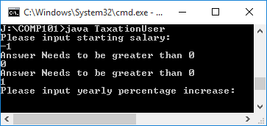

|  |  |
| --- | --- |
| Input | Expected |
| -1 | Prints invalid message |
| 0 | Prints invalid message |
| 1 | Continue |

*Test:* The input value for the number of yearly percentage increase should be an integer between 0 and 100.

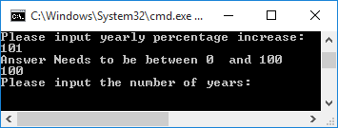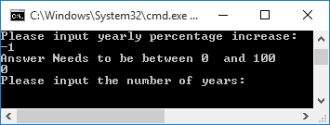

|  |  |
| --- | --- |
| Input | Expected |
| -1 | Prints invalid message |
| 0 | Continue |
| 101 | Prints invalid message |
| 100 | Continue |

*Test:* The input value for the number of years should be an integer above 0.

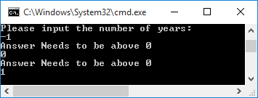

|  |  |
| --- | --- |
| Input | Expected |
| -1 | Prints invalid message |
| 0 | Prints invalid message |
| 1 | Continue |

*Test:* To see if the output values are correct using the users inputs. Also the program successfully adds the total for each part for the specific years.

(High Tax Band)

|  |  |
| --- | --- |
| Input | Expected |
| 35000 | Continue |
| 5 | Continue |
| 5 | Continue |

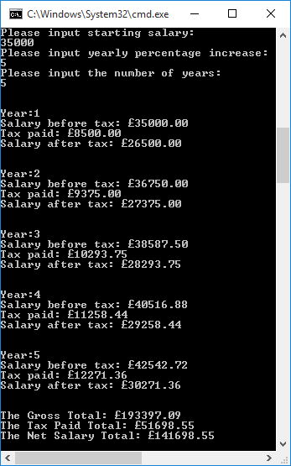

|  |
| --- |
| Expected Outcome |
| Year 1  35000.00  8500.00  26500.00 |
| Year 2  36750.00  9375.00  27375.00 |
| Year 3  38587.50  10293.75  28293.75 |
| Year 4  40516.88  11258.44  29258.44 |
| Year 5  42542.72  12271.36  30271.36 |
| 193397.09  51698.55  141698.55 |

*Test:* To see if the output values are correct using the users inputs. Also the program successfully adds the total for each part for the specific years.

(On the boundary. Low Tax Band)

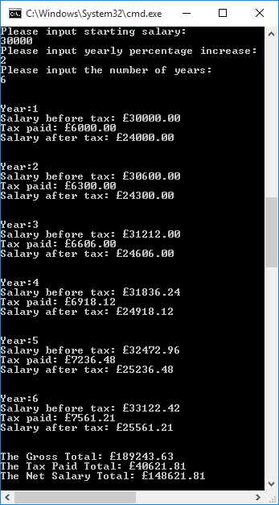

|  |  |
| --- | --- |
| Input | Expected |
| 30000 | Continue |
| 2 | Continue |
| 6 | Continue |

|  |
| --- |
| Expected Outcome |
| Year 1  3000.00  6000.00  24000.00 |
| Year 2  30600.00  6300.00  24300.00 |
| Year 3  31212.00  6606.00  24606.00 |
| Year 4  31836.24  6918.12  24918.12 |
| Year 5  32472.96  7236.48  25236.48 |
| Year 6  33122.42  7561.21  25561.21 |
| 189243.63  40621.81  148321.81 |

*Test:* To see if the output values are correct using the users inputs. Also the program successfully adds the total for each part for the specific years.

(Low Tax band)

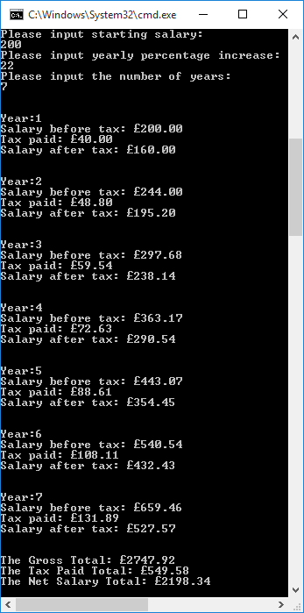

|  |  |
| --- | --- |
| Input | Expected |
| 200 | Continue |
| 22 | Continue |
| 7 | Continue |

|  |
| --- |
| Expected Outcome |
| Year 1  200.00  40.00  160.00 |
| Year 2  244.00  48.80  192.20 |
| Year 3  297.68  59.54  238.14 |
| Year 4  363.17  72.63  290.54 |
| Year 5  443.07  88.61  354.45 |
| Year 6  540.54  432.43 |
| Year 7  659.46  131.89  527.57 |
| 2747.92  549.58  2198.34 |